REGISTRATION DOCUMENT

17th National Model A Ford Rally

Based at the Copthorne Solway Hotel and

Solway Showgrounds, Masterton, Wairarapa.

23-28th February 2025

**Important comment.**

***As we have over 110 confirmed ‘Early-bird’ bookings for the 17th National Rally and due to the limitations of space at some of the route destinations for a lot of cars the Organizing Committee has decided to split the Rally into four equal groups colour coded RED, YELLOW, GREEN and BLUE.***

*If you have a group of friends you would prefer to travel with each day then you can allocate yourselves to a colour group when you come to the Registration Desk on Sunday p.m. 23rd February 2025. You don’t all have to be there at the same time to do this! Talk amongst yourselves well before the rally and decide who is to be in your group, then one of you, maybe the first arrival can enter the names on the list we have for each colour group at the reception desk.*

*If people are not concerned which group they are allocated to then they can select which colour they want and add their name/s to that list. As people arrive they can check the lists to see if their names have already been put in a colour group by one of their earlier arriving friends. If not, they can choose a colour group and add their own and their friends names to that group to start the process of getting their desired travel group together on one list.*

*We will then give you a coloured sticker for your name badge and two for your car, one for the front windscreen (right side) and the other for the rear window (right side). This will assist traffic marshals at the Solway Showgrounds to make sure you are in the correct assembly area for your group for each ‘run’ each day. The reason for having your group colour sticker on the rear window is (for example) so that you do not follow someone’s car with a green sticker when you are in red group! (Of course this does not apply when you are not on an organized daily ‘run’.)*

*There will be a map of the Solway Showgrounds in the Rally brochure showing where each colour group assembles each day for each ‘run’. The assembly point for, say, Cape Palliser is the same each day but a different colour group will be going to that assembly point and the subsequent ’run’, each day. It is important to study this map to familiarize yourselves with the four different assembly points where the four separate briefings and departures will occur each day. By the end of the week everyone will have done all four ‘runs’.*

FORMAL REGISTRATION FORM

Registration closes Sunday 10th November. No late entries accepted.

This is an editable ‘Word’ document, so you can fill it in on your computer then email it back to Martin Rees [nimafc.secretary@gmail.com](mailto:nimafc.secretary@gmail.com) or print it, fill it in by hand with a black pen then scan and email it back to me as an attachment. (You only need to send back pages 2, 3 & 7!) If you prefer to use NZ Post, send to: Rally Secretary, 298 Clifton Road, Whitford, R.D. 1 Howick, 2571 Auckland, NZ.

REGISTRANT’S DETAILS

|  |  |
| --- | --- |
| Driver’s name |  |
| Co-driver’s name |  |
| 1st passenger’s name |  |
| 2nd passenger’s name |  |
| Driver’s address |  |
|  |  |
|  |  |
|  |  |
| Email address |  |
| Preferred phone number |  |
| Your Model A Club |  |
| Allergy/dietary need | Name:  Requirement: |

YOUR VEHICLE DETAILS

|  |  |  |  |
| --- | --- | --- | --- |
| Vehicle year |  | Body style |  |
| Body colour |  | Registration No. |  |

HUBLEY RACING( Enter your name and car details if you want to compete)

|  |  |  |  |
| --- | --- | --- | --- |
| Your name |  | Body style of car |  |
| 2nd entrants name |  | Body style of car |  |

EVENT AND FUNCTION COSTS

|  |  |  |  |
| --- | --- | --- | --- |
| REGISTRATION | FEE | QUANTITY | **TOTAL** |
| RALLY ENTRY FEE- for vehicle and driver | $300 | x 1 | $300 |
| Co-driver/navigator | $300 | x 1 |  |
| Extra passenger’s entry fee | $250 | x |  |
| Extra Rally bumper badge (One included with Regn) | $25 | x |  |
| Rally cap with logo: Black | $36 | x |  |
| Rally cap with logo: Navy blue | $36 | x |  |

EVENTS AND FUNCTIONS/PROGRAM (Costs are per person)

|  |  |  |  |  |
| --- | --- | --- | --- | --- |
| **Sunday 23rd February 2025** |  |  |  |  |
| 1300-1830 | Registration desk open. **Copthorne Solway Hotel**. Collect ‘Goodie bags’ and assign your colour group, (Red / Yellow / Green / Blue) Get coloured stickers for name badge and car windscreen and rear window. | - |  |  |
| 1700-1830 | “Noggin’n’Natter” Cash Bar Solway Hotel | Self-pay | - | - |
| 1800-1900 | Meeting for Judges | - |  |  |
| 1900-2000 | Meeting of Club Delegates to discuss 2027 and 2029 National Rallies. (We suggest Club Captain, Vice-Captain & Secretary of each Regional Club) | - |  |  |
| 1830 -2200 | Dine at Solway Restaurant or any of your choice in Masterton. Get your group of friends together!  A list of restaurants and contact details is in the Rally brochure. | Self-pay | - | - |
|  |  |  |  |  |
| **Monday 24th February 2025** |  |  |  |  |
| 0700-0745 | Registration desk open | - |  |  |
| 0600-0730 | Solway restaurant breakfast | Self-pay | - | - |
| 0800 | Cars assemble for ‘Concours Judging’ at Solway Showgrounds | - |  |  |
| 0830-0900 | Cars assemble for ‘Public static display’ at Solway Showgrounds  You do not need to be in your ‘Colour Groups’ for this event | - |  |  |
| 1000-1600 | Public ‘Open Day’ and Grass Gymkhana, Solway Showgrounds | - |  |  |
| 0800-1600 | Coffee truck and Food trucks all day at Solway Showgrounds | Self-pay | - | - |
| 1630-1700 | Hubley Racing practice. Solway Hotel | - |  |  |
| 1700-1830 | Timed **Hubley Racing** competition. Solway Hotel | - |  |  |
| 1830-1900 | Pre-dinner drinks. Cash bar. Solway Hotel | Self-pay | - | - |
| 1900-2200 | **Informal Dinner** Solway Hotel. Guest Speaker.  The cost of dinner is included in the registration fees for the Driver, co-driver and passengers listed above. | $45 per person | - | - |
|  |  |  |  |  |
| **Tuesday 25th February 2025** |  |  |  |  |
| 0700-0745 | Registration desk open | - |  |  |
| 0600-0730 | Solway restaurant breakfast | Self-pay | - | - |
| 0800 | Cars assemble for ‘Long Runs’ at Solway Showgrounds. Depart 0830. Check your colour group! | - |  |  |
| 0830 | Cars assemble for ‘Short Runs’ at Solway Showgrounds. Depart 0900. Check your colour group! | - |  |  |
| **Lunch** | Provided on each route/run.  The cost of lunch is included in the registration fees for the Driver, co-driver and passengers listed above. | ($25 pp) | - | - |
| 1730-1830 | ‘Noggin’n’Natter’ Solway Cash Bar | Self-pay | - | - |
| 1830-2200 | ‘**Free Evening’**. Dine at a local restaurant with a group of friends.  A list of restaurants and contact details is in the Rally brochure. | Self-pay | - | - |
|  |  |  |  |  |
| **Wednesday 26th February 2025** |  |  |  |  |
| 0700-0745 | Registration desk open | - |  |  |
| 0600-0730 | Solway restaurant breakfast | Self-pay | - | - |
| 0800 | Cars assemble for ‘Long Runs’ at Solway Showgrounds. Depart 0830. Check your colour group! | - |  |  |
| 0830 | Cars assemble for ‘Short Runs’ at Solway Showgrounds. Depart 0900. Check your colour group! | - |  |  |
| **Lunch** | Provided on each route/run.  The cost of lunch is included in the registration fee for the Driver, co-driver and passengers listed above. | ($25 pp) | - | - |
| 1730-1900 | ‘Noggin’n’Natter’ Solway Cash Bar | Self-pay | - | - |
| 1900-2200 | Rally Dinner and Quiz night .  The cost of dinner is included in the registration fees for the Driver, co-driver and passengers listed above. | $50 per person | - | - |

|  |  |  |  |  |
| --- | --- | --- | --- | --- |
| **Thursday 27th February 2025** |  |  |  |  |
| 0700-0745 | Registration desk open | - |  |  |
| 0600-0730 | Solway restaurant breakfast | Self-pay | - | - |
| 0800 | Cars assemble for ‘Long Runs’ at Solway Showgrounds. Depart 0830. Check your colour group! | - |  |  |
| 0830 | Cars assemble for ‘Short Runs’ at Solway Showgrounds. Depart 0900. Check your colour group! | - |  |  |
| **Lunch** | Provided on each route/run.  The cost of lunch is included in the registration fee for the Driver, co-driver and passengers listed above. | ($25 pp) | - | - |
| 1700-1830 | ‘Noggin’n’Natter’ Solway Cash Bar | Self-pay | - | - |
| 1830-2200 | ‘**Free Evening’**. Dine at a local restaurant with a group of friends.  A list of restaurants and contact details is in the Rally brochure. | Self-pay | - | - |
|  |  |  |  |  |

|  |  |  |  |  |
| --- | --- | --- | --- | --- |
| **Friday 28th February 2025** |  |  |  |  |
| 0700-0745 | Registration desk open | - |  |  |
| 0600-0730 | Solway restaurant breakfast | Self-pay | - | - |
| 0800 | Cars assemble for ‘Long Runs’ at Solway Showgrounds. Depart 0830. Check your colour group! | - |  |  |
| 0830 | Cars assemble for ‘Short Runs’ at Solway Showgrounds. Depart 0900. Check your colour group! | - |  |  |
| **Lunch** | Provided on each route/run The cost of lunch is included in the registration fees for the Driver, co-driver and passengers listed above. | ($25 pp) | - | - |
| 1730-1900 | ‘Noggin’n’Natter’ Solway cash Bar | Self-pay | - | - |
| 1900-2200 | **Gala Dinner in Period Costume.**  Guest Speaker.  The cost of dinner is included in the registration fees for the Driver, co-driver and passengers listed above. | $55pp | - | - |

|  |  |  |  |  |
| --- | --- | --- | --- | --- |
| **Saturday 1st March 2025** | This is ‘optional’, NOT part of the Rally. |  |  |  |
| 0700-1000 | Farewell Breakfast, Solway Hotel Restaurant. Meet your friends for a final chat and make travel arrangements for the way home.  Farewell. “Bon Voyage”. | Self-pay | - | - |
|  |  |  |  |  |
| **Additional Notes** | 1. If you have a co-driver or navigator (most of you will) please make sure you listed that person with a fee of $300 in the first section. (This covers their dinners and lunches and sundry rally expenses) | - |  |  |
|  | 2. If you have extra passengers who will be attending the whole rally, dinners and lunches, please make sure you list them above in the first section at a cost of $250 to cover their dinners & lunches. |  |  |  |
|  | 3. if you made an ‘Early-bird’ registration of $40 then deduct that from your total.(see below) | - |  |  |
|  | 4. If you are traveling alone with no co-driver then your cost is the $300 entry fee (to cover dinners, lunches and sundry rally expenses) plus cost of a cap and any extra badges you may want |  |  |  |
|  | 5. Clothing for all people is purchased separately through Custom Threadz (see below) |  |  |  |
|  | 6. The Rally Committee is supplying the caps, embroidered with the Rally logo. Caps will be in your ‘goodie bag’. |  |  |  |

|  |  |  |  |  |
| --- | --- | --- | --- | --- |
| **“Tally table”** | **Total for Car & Driver Registration, Co-driver registration, passenger registration, caps and extra badges.** |  |  | $ |
|  | Less ‘Early-Bird’ registration. See note 3 above. | -$40 |  |  |
|  | **Overall Total** to pay |  |  | **$** |

|  |  |
| --- | --- |
| Please pay to NIMAFC ASB Rally Account No | 12 3068 0187485-51 |
| **Note the suffix -51. Please make sure you change from our Club Account -00 suffix which may be embedded in your cell-phone or computer online banking program. Please use the -51 suffix, otherwise the money goes to the wrong account and will cause us lots of problems/headaches! -51 is the correct suffix, NOT -00 !!**  **Please include your initials and surname in the ‘Particulars’ field, car registration number for the ‘code’ field, and put ‘17th Rally’ in the ‘Reference’ field.**  *Please also email our Treasurer, Kirsten, to let her know you have made your payment and what the total comes to. She will then send you a receipt, which will confirm your Formal Registration. Her email address is* **nimafc.treasurer@gmail.com** | |

RALLY CLOTHING/APPAREL

Custom Threadz is our clothing supplier, situated at 16 Queen Street, Pukekohe 2120.

They have a vast range of clothing available. We are not taking clothing orders from you.

The Rally Committee (plus wives) have looked at the range of clothing available and have made the following selection that we recommend to our ‘Model A Mates’.

A description of each item is given below plus its code and its web-link. Screen shots of the items are also shown below as a ready reference, but we suggest you open the weblink by clicking on it or highlight/copy/paste it to the search bar in your web browser to find the item and look at the colour range and sizes available.

Please email Mala Uka with your order using the ‘**Clothing Order Form’** quoting the **code number, description, colour and size you want (use sizes as mentioned for each item on its web-page, please) for each item with its quoted price and number of garments for each code. Embroidering each clothing item with the Rally logo on the left upper chest costs $10 plus GST. Please include your name, email, phone number and home address with your order.** Mala will then send you an invoice for your order with your order number and the Custom Threadz bank account number so you can pay online for your clothing choices.

The clothing will then be sent to your home address by courier so you will have your clothing before the Rally. A courier charge will be added to your clothing order which will vary according to the size of package and whether you have a rural delivery address or not. Clothing orders should be made by the end of November to give plenty of time for the items to be supplied bearing in mind the country ‘shuts down‘ for holidays from mid-December to mid-January.

If you live overseas and do not want your clothing sent to you to reduce weight in your checked baggage, you may use the following address on the order form:

Care of: 298 Clifton Road, R.D. 1 Howick, Auckland 2571, NZ.

Your clothing order will be taken to the Rally in Masterton for you to collect at the Rally Registration Desk at the Copthorne Solway Hotel.

There are many colour options for each garment, some more than others. You are free to order whatever colour you like. Some garments have accents in different colours. The colour theme for the Rally is ‘yellow/gold and black’. We will be ordering black garments with the gold/yellow accents (where possible) to support the Rally colour theme!

When you have made your selection please email it to:

Mala Uka [info@customthreadz.co.nz](mailto:info@customthreadz.co.nz). Mobile 021 049 3289. Land-line 09 238 4798.

Clearly some people will not want to purchase any extra Model A branded clothing whereas some my wish to get a T-shirt, a polo shirt, a casual jacket and maybe a waterproof jacket. The choice is yours. You will have fun looking at the suggested options and making colour choices!

CLOTHING RECOMMENDATIONS

|  |  |  |
| --- | --- | --- |
| **CODE** | **Description** | **Price** $NZ excl GST |
| T101 | Men’s ‘Outline’ cotton T-shirt crew neck, lots of colours.  Web link: <https://www.cloke.co.nz/mens-womens/t-shirts/outline-tee-mens> | $15.65 |
| T201 | Women’s ‘Silhouette’ cotton T-shirt, crew neck, lots of colours  Web link: <https://www.cloke.co.nz/mens-womens/t-shirts/silhouette-tee-womens> | $15.65 |
| P313MS | Men’s Focus short sleeved Polo shirt, many colours, suggest black or navy with gold trim to collar. Web link: <https://www.bizcollection.co.nz/product/nz/p313ms> | $25.44 |
| P313LS | Women’s Focus short sleeved Polo, many colours with different trim colours for collar. Web Link: <https://www.bizcollection.co.nz/product/nz/p313ls> | $25.44 |
| 1515 | Olympus men’s soft shell vest. Web link: <https://wholesale.aussiepacific.co.nz/products/olympus-mens-vests-1515?_pos=1&_sid=c7e5d54b3&_ss=r> | $51.95 |
| 2515 | Olympus women’s soft shell vest. Web link: <https://wholesale.aussiepacific.co.nz/products/olympus-lady-vests-2515?_pos=1&_sid=ff1f837d1&_ss=r> | $51.95 |
| SSA | Men’s Balfour soft shell jacket. Web link: <https://www.cloke.co.nz/mens-womens/jackets-softshells/balfour-softshell-jacket-mens> | $65.21 |
| SSG | Women’s Balfour soft shell jacket. Web link: <https://www.cloke.co.nz/mens-womens/jackets-softshells/balfour-softshell-jacket-womens> | $65.21 |
| ZT360 | Unisex ’Zymik’ Full zip Knit jacket in Navy, Grey or Gunmetal.  Web link: <https://www.syzmik.com/product/au/zt360/> | $59.20 |
| J132L | Women’s ‘Eclipse’ Waterproof hooded jacket 100%PE. Quilted warm lining. Black or Navy Blue. Web link:  https://www.BizCollection.co.nz/product/nz/j132l | $118.61 |
| J132M | Men’s ‘Eclipse’ waterproof jacket in Navy Blue or Black. 100% P E. Quilted warm lining. Web Link: https://www.BizCollection.co.nz/product/nz/j132m | $118.61 |

**Screen shots of the clothing items listed above**

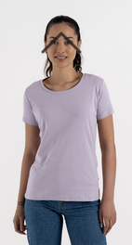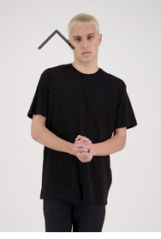

Men’s ‘Outline’ tee shirt Women’s ‘Silhouette’ Tee Shirt

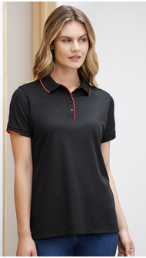

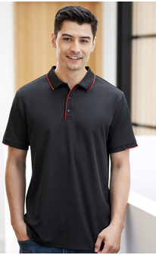

Men’s ‘Focus’ Polo shirt Women’s ‘Focus’ Polo shirt

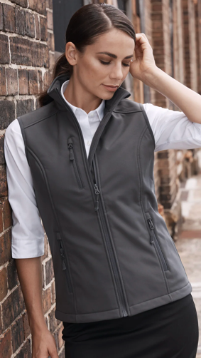

Men’s ‘Olympus’ vest Women’s ‘Olympus’ vest

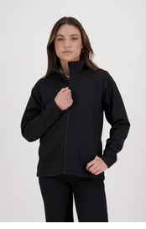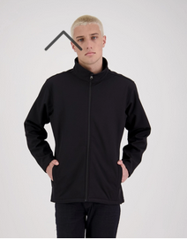

Men’s ‘Balfour’ soft shell jacket Women’s ‘Balfour’ soft shell jacket

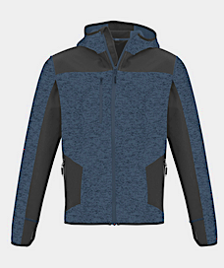

Unisex ‘Zymik’ knitted jacket

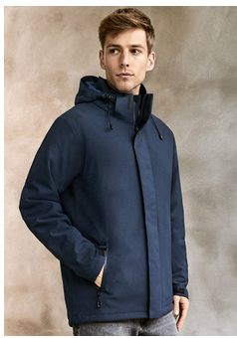

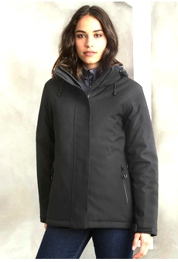Women’s ‘Eclipse‘ jacket Men’s ‘Eclipse’ jacket