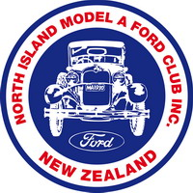
NORTH ISLAND MODEL A FORD CLUB INC
Website: www.modelafordclub.co.nz
Facebook: North Island Model A Ford Club

New Member Application Form (NIMAFC)
Applicant’s full names: _______________________________________________
Residential Address: _______________________________________________
_______________________________________________
_______________________________________________
Postal Address: (if different from residential)
_______________________________________________
Contact Details: Home: _______________ Mobile: ___________________
E-Mail Address: ____________________________________________________
Year and Body Style of Vehicle: ________________________________________
Colour, Registration No: ________________________________________
The current annual membership fees are:
Individual/Family Annual Membership 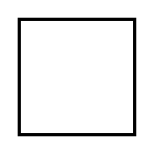 $45.00 (includes emailed Newsletters)
Total Individual/Family NEW Membership $65.00 (incl. $20 for cost of Club name badge)
Youth Associate (under 22) No charge (Check one membership type)
The Club’s financial year is 1st September – 31st August. Our AGM is in October each year.

The Committee reserves the right to refuse any application at its discretion. New member applications are assessed at the monthly Club Committee meetings usually held on the first or second Tuesday of each month.
Please wait to receive ‘approval’ of membership from the Secretary and also an ‘invoice’ for payment from the Treasurer.

Please use Internet Banking to make Payment to:
ASB Bank Account Number 12 3068 0187485-00
North Island Model A Ford Club Inc.
Particulars: Surname & Initials. Code: Subs. Reference: Invoice No.
If you are unable to pay by Internet Banking please deposit directly into Club account, as mentioned above, at your local bank branch.
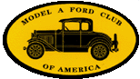  A Chapter of the Model A Ford Club of America | 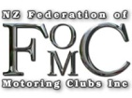  A Member of the NZ Federation of Motoring Clubs |   A Member of the Model A Restorers Club
NORTH ISLAND MODEL A FORD CLUB INC
Website: www.modelafordclub.co.nz
Facebook: North Island Model A Ford Club

The Incorporated Society’s Act 2023 requires the following questions to be asked and answered.
Please answer the items below by placing a ‘x’ in or beside the box to indicate your choice.
1. I agree that I have not been coerced into joining the North Island Model A Ford Club.
2. I have been coerced into joining the North Island Model A Ford Club.
3. I authorise my contact details to be made available to other Club members .
Note: Your home address is not given to other Club members, but your phone number, email and town of residence are included in the membership spreadsheet that is sent to all members.
4. I do not wish to have my contact details shared with other Club members.

Applicant’s Signature: ____________________________ Date: ___________________

If you need to post your membership form, please send it to:
Model A Ford Club Secretary,
298 Clifton Road, Whitford, R D 1 Howick 2571, Auckland.

You do not need to own a Model A Ford to be a member of our Club, you just need to have an interest in this vehicle and enjoy the friendship and support of like-minded Model A Ford enthusiasts!

This form is a computer friendly Word document so FILLABLE / EDITABLE on the computer. Just save a copy to your files , Edit, Save, then send as an email attachment to nimafc.secretary@gmail.com Thank you.

A Chapter of the Model A Ford Club of America | A Member of the NZ Federation of Motoring Clubs | A Member of the Model A Restorers Club

