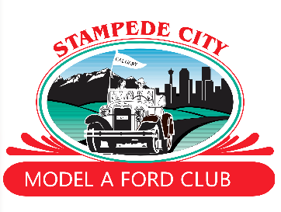
Stampede City Model A Ford Club Canada
The Ford Script newsletter –
https://scmafc.ca
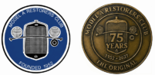
Ford Model A Restorers Club
The Original Ford Model ‘A’ Club since 1952 -
https://modelarestorersclub.org

Oakleaf Model A Restorers Club
https://www.oakleafregion.org
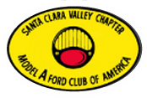
MARC/MAFCA Model A Ford Club
Columbus, Indiana
Going Places newsletter –
https://www.modelacolumbus.org
Santa Clara Valley Chapter of America
The Ford Script newsletter -
https://www.scvcma.org
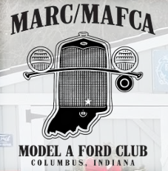
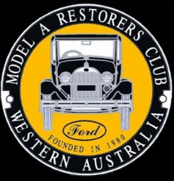
Model A Restorers Club of Western Australia, Inc
Western Model a News newsletter –
http://www.modelafordclub.com.au
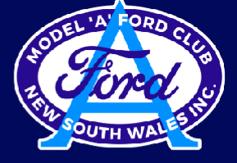
Model A Ford Club of New South Wales
Model A Flyer newsletter -
https://www.modelafordclubofnsw.com.au

